Dear Student,

Thank you for coming in for your resume review. This is a valuable service provided to you by MIU. These notes MUST be kept until you start your CPT position. To continue the process of getting your resume ready, complete the following step:

1. Take a picture of the recommendations made on your resume.
2. Make changes to your resume using track changes including customizing your Linkedin URL (see below):

How to use Track Changes in MS Word

1. Open your resume in MS Word
2. Under Review select Track Changes
3. Select Track Changes from the dropdown menu
4. Make changes and save
5. Send back to contact at resume service (the person who sent you the worksheets)
6. Send your edited resume with track changes and photo attached back to the resume service.   
   **NOTE: The resume service will NOT make the changes if your photos aren’t attached.**

Customizing your Linkdin URL:

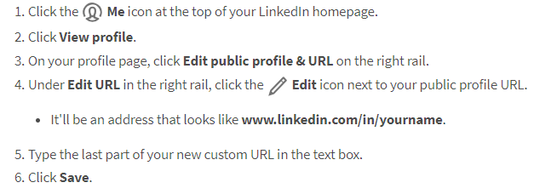

Thank you,

Sara

Sara Robinson, MSH